2021 Award Winner

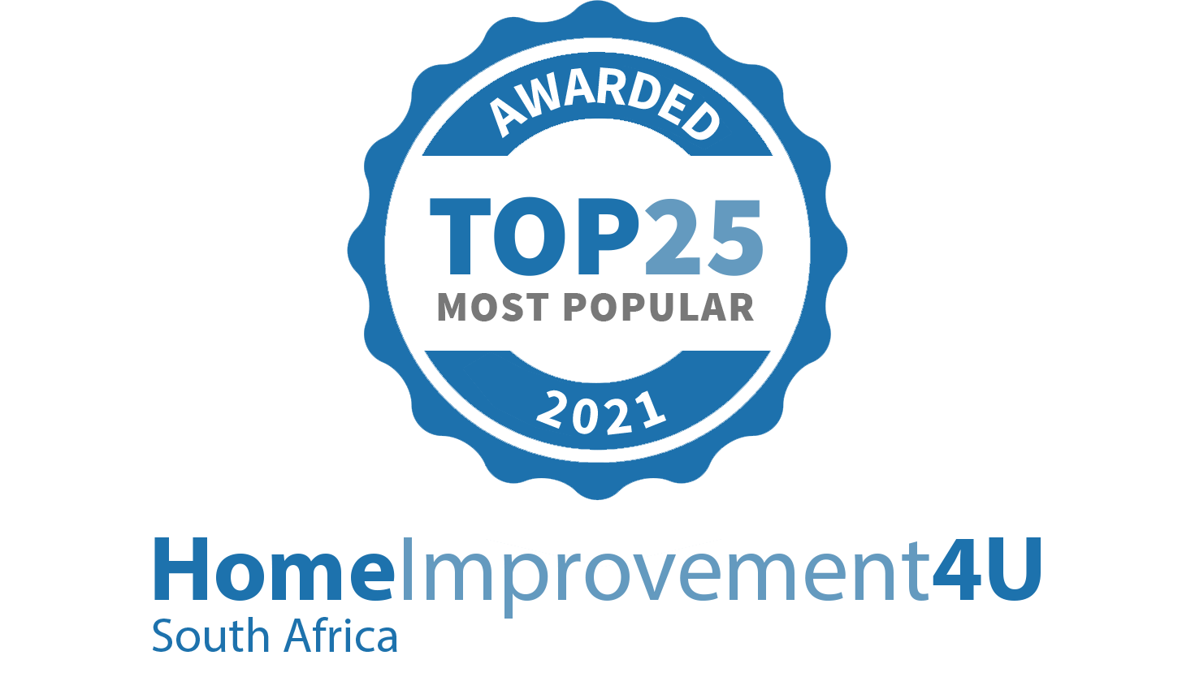

South Africa's leading online marketplace for home

improvements

Awarded to:

**Proskim Construction PSC**

**Roof water proofing - Brackenfell**

[Powered by TCPDF (www.tcpdf.org)](http://www.tcpdf.org/)